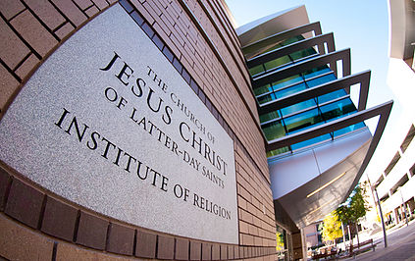  wyomingldsfoundation.org  Wyoming  LDS Foundation Scholarship  Available to undergrad students attending a Wyoming University,  Community, or Junior College. Current College students and High School seniors can apply. | Scholarship recipients will need to enroll and attend LDS Institute Classes  __________  The intent of the Wyoming LDS Foundation is to promote attendance at the University of Wyoming or a Wyoming community or junior college and the LDS Institute of Religion.  ________  Go to  wyomingldsfoundation.org  to apply  Deadline  May 17, 2019  Wyoming LDS Foundation  6746 Beckle Road  Cheyenne, WY 82009  scholarship@wyomingldsfoundation.org
To donate to this scholarship, please visit the website for details

